Research in the news: Yale researchers find surprising trigger of new brain cell growth
By Bill Hathaway February 19, 2015
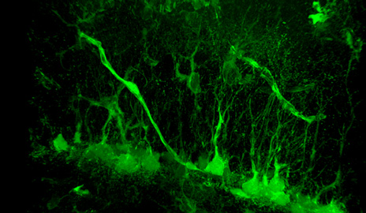 Neural stem cells and nearby blood vessels that express key molecule VEGFR3 are seen in green. VEGFR3 appears to play a role in both formation of new brain cells as well as blood vessels.

Scientists have discovered that the human brain can produce new neurons, but exactly how those cells are produced and what purpose they serve are not well understood. Now a study by Yale researchers shows that key developmental factors that control the formation of blood vessels are also necessary for activating brain stem cells.
Yale neurobiologist Jean-Leon Thomas and colleagues, in collaboration with vascular biologist Anne Eichmann, found that neural stem cells lacking a receptor for vascular endothelial growth factor (VEGFR3) produce fewer new brain cells in the hippocampus of mice. In addition, mice lacking VEGFR3 exhibit more anxiety than mice with intact receptors in stem cells.
Surprisingly, said the researchers, a related VEGF molecule does not stimulate brain blood vessels at doses that activate brain stem cells, which suggests that this factor may be used specifically in the treatment of neurological diseases. The team, including first author Jinah Han, reported their findings Feb. 19 in the journal Cell Reports.

